Patient Service Center Guide

Clinical Staff Workflow

The Staff Message – Starting the PSC Process
When a patient needs to go to a Patient Service Center (PSC) for a lab draw that WHA cannot draw, follow this workflow.
Once the lab order has been placed in Epic, you will send a staff message to your clinic’s Lab Pool.
- Open a new, blank staff message.
- To: P WHA LAB [Site abbreviation here] POOL
- Subject: [LabCorp/Quest] PSC Orders
- Attach your patient’s chart.
- In the body of the staff message type: .WHALCPSC
- Fill in the variables using F2 or the mouse.
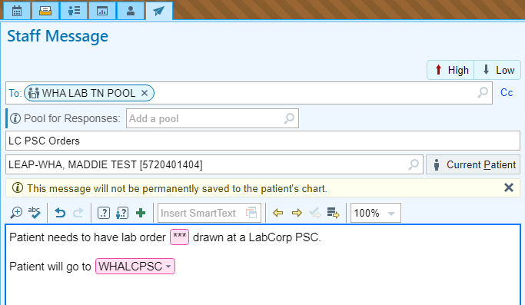
  - - The lab order to be sent out
  - - Which PSC location the patient will be going to
**Note: Depending on the PSC location, instructions will be included in the smartphrase for how the Lab Assistant should send the order. See examples of staff messages that may come to the Lab Pool InBasket on the next page.**

Legacy PSC Location Example
For a list of all LHS PCS Locations click here.
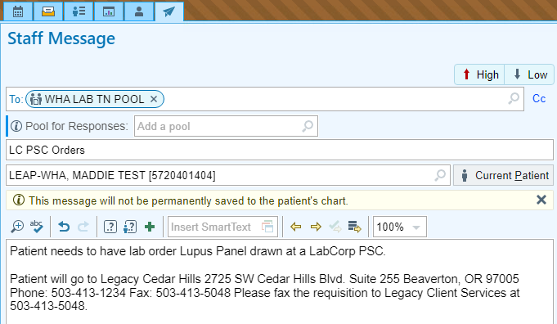
Providence/Other PSC Location Example
For a list of all other LabCorp PSC Locations click here.
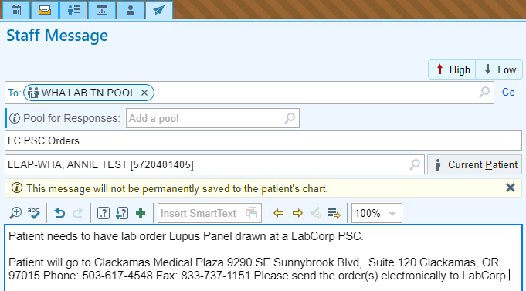

Quest PSC Location Example
For a list of all Quest PSC Locations click here.
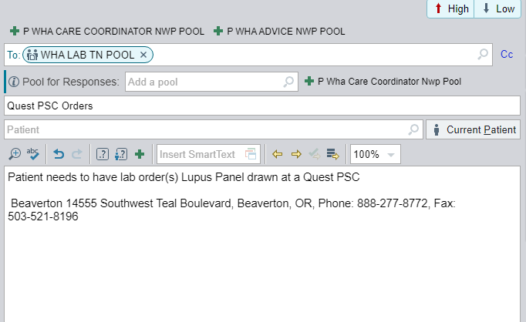

Scripting for Patients Regarding Labs

In the circumstance the provider orders multiple labs for the patient, we encourage the patient complete what WHA can draw and process within WHA and the labs we cannot draw to be completed at the patient’s chosen PSC.
We understand this means the patient is being drawn twice, however, with our recent experience of delays in receiving lab results from LabCorp, this is in the patient’s best interest. Ultimately, if the patient declines being drawn twice, please follow the process above and send all orders to the PSC of the patient's choosing. Please utilize the scripting below:
"Hello, please confirm that these are the labs the provider has ordered for you today: ____. We can draw the following tests here ____ and process them promptly. They should result in the next 1-2 business days. However, due to the specific stability & specimen requirements, it's necessary for the following labs_____ to be drawn at an outpatient draw station. Considering the longer turnaround time for results with outside laboratories, we suggest having the labs that WHA can process today drawn first. Then, you can follow up with the outside lab of your choice for the remaining labs. We understand this means you will have two draws and potentially two separate lab costs. How would you like to proceed?"
Please make sure to advise the patient labs may take 3-5 business days or longer resulting from LabCorp.

Lab Assistant Orchard Workflows

Draw Station Electronic Order Workflow (Quest, Providence, and Legacy)
Once an order is signed in Epic, it will release into Orchard. This is the workflow to use for a patient who needs to go to a LabCorp PSC.
If you open an order in Release Stored Orders (RSO) in Orchard and you get a pop up which states the patient needs to be sent to a draw station, close the pop up and back out of the order without saving any data.
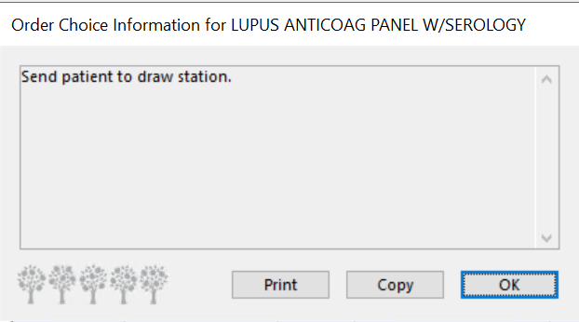
- Open Release Stored Orders (RSO) in Orchard.
- Highlight the orders that need to be sent to the LabCorp PSC.
- Click Edit via Entry in the bottom right corner of RSO.
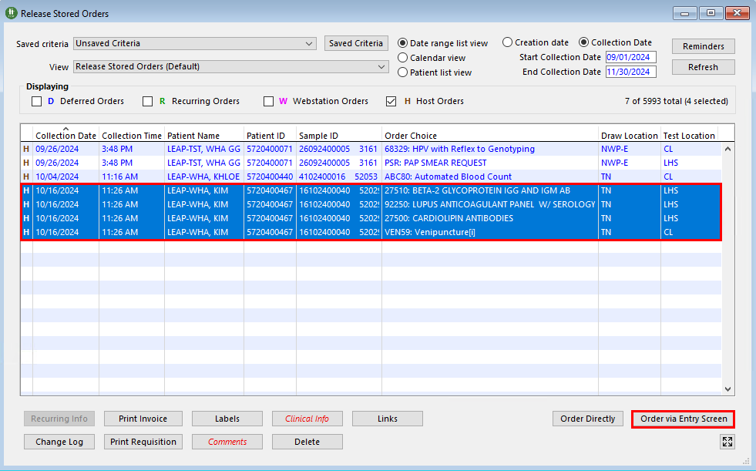

- Change the following fields:
  - Draw Location: QST, LABCP
  - Phlebotomist: Quest/LabCorp Phlebotomy
  - Location: QST/LABCP
  - Collection Date: 00/00/0000 Time: 12:00 PM
  - Received Date: 00/00/0000 Time: 12:00 PM
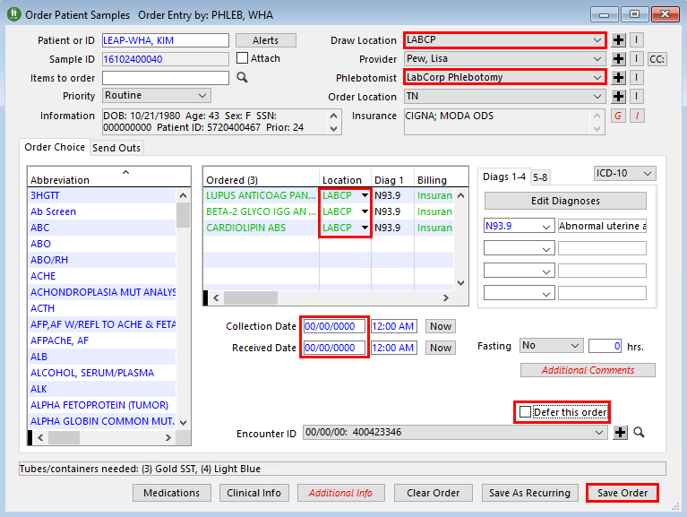

- Uncheck the Defer this order box in the bottom right corner of the window.
- Click Save Order.

- In the toolbar at the top of Orchard, click Laboratory to open the drop down menu.
- Select the Reference Labs activity.
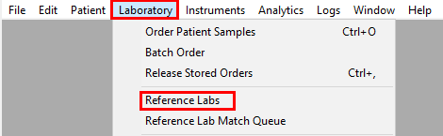

- In the Reference Labs activity go to the Quest or LAB CORP tab.
- Ensure the Status is set as Waiting to be released.
- Select the applicable orders. Hold Ctrl while clicking the labs to select more than one at a time.
- Click Create Batch, hold Alt to bypass the Print dialog box.
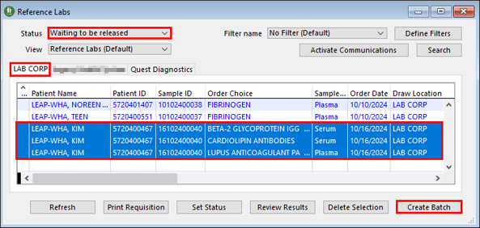
**Note: Once the batch is created, you can no longer access the orders.**

If you forgot to uncheck “Defer this order”
- Go to RSO.
- Select the appropriate orders.
- In the Saved Criteria drop down, select Quest Diagnostics or LabCorp PSC Orders.
- Ensure the Start and Collection Dates are both 00/00/0000.
- Ensure the Deferred Orders box is the only one checked.
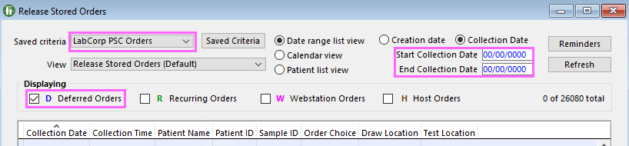
- Click Refresh.
- Locate the orders and start at the beginning of the workflow.

Completing the Documentation
Once the Quest or LabCorp order has been sent out, you will need to document that this has been completed.
- In the InBasket, find the PSC staff message.
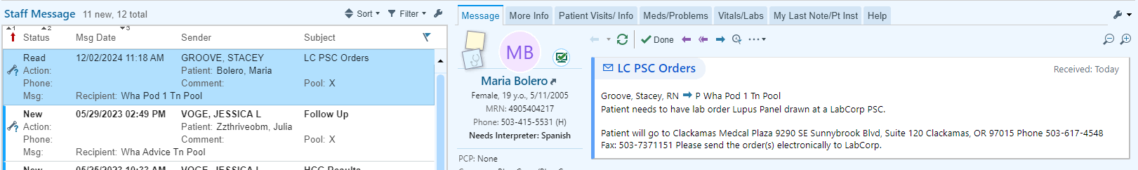

- Click Telephone Call.

- A Patient Encounter Creation window will open.
- Select a Provider, this should be the provider who ordered the test.
- Ensure the Department is correct.
- Click Create.
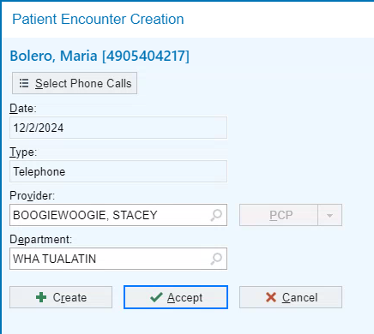
- A Copy Message Text? window opens. Click Yes. This will copy the staff message into the Note of the telephone encounter.
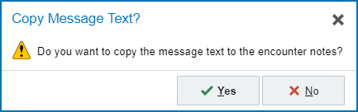

- In Contacts click Other.
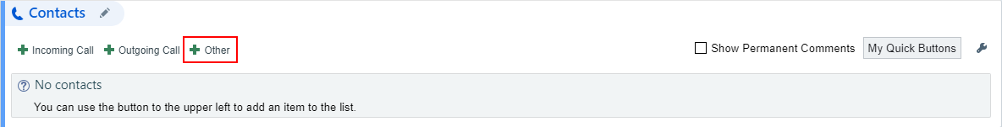

- Method: File - used for orders being sent electronically via Orchard.
- Type: Outgoing
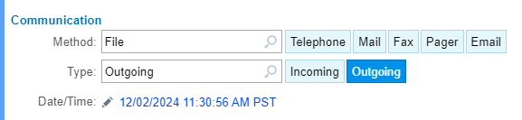

- Contact Name: Quest Diagnostics or LabCorp PSC
- Relationship: Lab
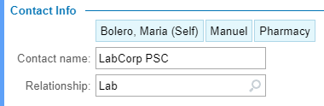

- Click Accept.

- Reason for Call: Lab Orders
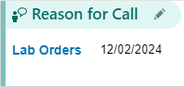

- Click Create Note to start a new blank note.
- In the blank Note, type: .WHALABASSITNOTEDOCPSC and complete the appropriate variables. Erase the text that is not needed.
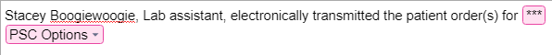
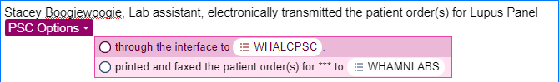
  - Through the interface – used for Providence or other PSC locations.
  - Printed and faxed – used for Legacy LabCorp locations.

- Click Sign Encounter 

